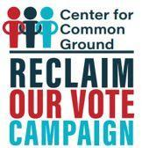

RECLAIM OUR VOTE is a volunteer-driven, nonpartisan voter outreach campaign to help de-registered voters of color re-register to vote. It is organized by the Center for Common Ground of Virginia, with the help of the NAACP, Black Voters Matter, Mi Familia Vota and other organizations. We’re contacting de-registered voting eligible voters of color in Virginia, North Carolina, Mississippi, Texas, Arizona and additional states, to help them re-register and get to the polls.

To volunteer with the postcard campaign contact Claire at clairepm19@yahoo.com